

IEEE Computer Society Bangalore Chapter
Internship and Mentorship Program – 2025

Report on

Project ID: “Ai Hotel Receptionist”

Submitted by

NAME COLLEGE
P Prithvi Raj Kandan Global Academy Of Technology

Under the Mentorship of

Dr Roopa BS
Head Of Department, AIML, GAT

Introduction

Artificial Intelligence has redefined how businesses interact with their customers, shifting traditional manual processes into more efficient, automated, and intelligent systems. The hospitality industry, in particular, demands continuous customer engagement, quick query resolution, and personalized service — areas where AI-driven solutions can provide significant value. This project, developed as part of my IEEE Internship and Mentorship Program, focuses on building an AI-powered Hotel Receptionist that leverages natural language processing, speech technologies, and intelligent decision-making frameworks to simulate the role of a human receptionist.
The core workflow integrates three essential AI components: speech-to-text (STT) using Deepgram, language model reasoning via LangChain and openai/gpt-oss-20b and text-to-speech (TTS) powered by ElevenLabs. Guests interact with the system by speaking directly into a microphone, after which their speech is transcribed, interpreted, and responded to in natural, human-like voice output. To ensure realistic and context-aware conversations, the system maintains conversation history using LangChain’s memory modules, allowing it to recall past interactions during a session. Moreover, an intelligent output parser was implemented to convert structured query results, such as database tables or markdown-style formatting, into user-friendly spoken responses. This eliminates the robotic nature of AI replies and makes the system sound closer to a real receptionist.
From a technological perspective, the project demonstrates the integration of multiple APIs and frameworks, seamless backend–frontend communication through FastAPI and a browser-based UI, and robust performance monitoring. More importantly, it reflects the practical application of AI to address real-world challenges in hospitality management, where automation and personalization must coexist to improve the customer experience.

Existing System

Traditionally, the role of hotel receptionists has been fulfilled by human staff who manage guest interactions in person. Guests approach the reception desk for inquiries, reservations, check-ins, and complaints. While this system offers personal interaction, it has several limitations: dependency on staff availability, the potential for human errors in record keeping, and reduced efficiency during peak hours. The cost of training and maintaining round-the-clock staff further increases operational overhead.
The first wave of automation came through telephonic and email-based reservation systems. Guests could call or send emails to confirm bookings or request information. While convenient, this approach remained dependent on staff availability, often resulting in long waiting times, missed calls, or delayed responses to emails. It lacked scalability and was unable to handle simultaneous high volumes of requests effectively.
The adoption of hotel websites and booking portals improved guest convenience by allowing customers to check availability and book rooms online. However, these systems were static and lacked conversational intelligence. They could not provide dynamic responses to follow-up queries such as “Which rooms are best suited for families?” or “What additional facilities are available?” Users were limited to navigating predefined menus, which restricted personalization and engagement.
To further improve guest interaction, some hotels introduced rule-based chatbots on websites or messaging apps. These bots could respond to FAQs or guide users through simple booking processes. However, they struggled with contextual understanding. For example, if a guest asked, “What are the three types of rooms you mentioned earlier?” the bot would often fail, leading to repetitive or irrelevant responses. This lack of adaptability caused user frustration and limited adoption.
With respect to ai agents in the field of hospitality, conversational ai which include STT (speech to text) and TTS (text to speech) or direct STS (speech to speech) existing systems are :-

Google AI Studio: Gemini 2.0 Flash
  - Core Functionality: Streams real-time audio processing with ultra-low latency (sub-500ms). Leverages Gemini 2.0’s multimodal capabilities to interpret contextual speech (e.g., accents, interruptions).
  - Strengths: Exceptional at dynamic Q&A (e.g., answering guest queries about amenities). Supports 50+ languages and emotion-aware responses.

Workflow Gaps:
    - No PMS Integration: Cannot access hotel databases (e.g., room availability in Opera PMS).
    - Email Blindspots: Lacks APIs for Stripe transactions or automated email triggers (e.g., invoice generation).

    - Static Knowledge: Relies on predefined datasets, not real-time PMS data synchronization.

Eleven Labs: Conversational AI Agent
  - Core Functionality: End-to-end pipeline (ASR → LLM → TTS) with human-like prosody. Specializes in emotional resonance (e.g., empathetic complaint handling).
  - Strengths: Context retention across long dialogues; custom voice cloning for brand consistency.

Workflow Gaps:
    - Zero Backend Automation: No tools to connect to reservation systems (e.g., Amadeus) or payment gateways.
    - Email/Invoice Limitation: Cannot send confirmations or process cancellations programmatically.
    - Isolated Design: Operates as a standalone voice interface without CRM/PMS hooks.

While these S2S models excel in fluid conversational experiences, they operate as voice interfaces rather than integrated workflow agents. Critically, none support end-to-end automation required for hotel operations:
  - No PMS Integration: Cannot query/modify room inventories, check-in/out statuses, or housekeeping schedules.
  - Custom Workflow Inflexibility: Cannot execute multi-step tasks (e.g., "Cancel booking
→ Refund deposit → Notify housekeeping").

Proposed System
The proposed system introduces a unified AI-powered hotel receptionist that seamlessly integrates speech-to-text (STT), natural language processing (NLP), and text-to-speech (TTS) into a single workflow. Unlike the existing disjointed endpoints, the system is built around a centralized /voicebot endpoint, which performs all three tasks in sequence — transcription, query processing, and voice response — within one call. This significantly reduces latency, simplifies frontend integration, and ensures a natural conversational flow.

Speech-to-Text (STT)
The first stage of the workflow is speech recognition, powered by Deepgram’s Nova-2 model. Guest audio, typically captured in webm; codecs=opus format via the browser’s MediaRecorder API, is sent to the backend. To ensure compatibility, the backend uses pydub with ffmpeg to transcode the file if required. The transcription engine produces highly accurate text even in noisy environments, which is essential for front-desk scenarios. The transcribed text is returned both for display in the chat interface and for further processing by the agent.
Conversational Agent (LLM + LangChain)
The transcribed text is passed to a LangChain-powered agent that uses the openai/gpt-oss-20b model hosted on Groq. The agent is equipped with ConversationBufferMemory, allowing it to recall previous user queries and responses during a session. This ensures contextual continuity — if a guest asks “How many rooms are available?” followed by “What types are they?”, the system links the second query back to the first. The agent is also integrated with a hotel database for retrieving structured data such as room types, prices, and availability.

Output Parsing
Since LLM and database responses often include Markdown formatting (tables, bold markers), a custom parse_agent_response() function was implemented. This parser converts raw outputs into human-friendly sentences, ensuring that TTS does not read out formatting artifacts like | or **. For example, a database table listing rooms is transformed into: “Room
104 is priced at 1,500 per night and accommodates 2 guests. Room 105 has similar specifications.” This step is crucial for delivering professional, natural-sounding voice responses.

Text-to-Speech (TTS)
Once parsed, the response is synthesized into speech using ElevenLabs’ Text-to-Speech API. The system employs the Monolingual v1 model with configurable voice IDs (e.g., Rachel). Audio is encoded as MP3, stored in a /downloads directory for debugging, and returned as base64 for immediate playback in the browser. By decoupling the TTS engine from raw outputs, the system guarantees consistency between displayed text and spoken replies.

Frontend Integration
The frontend, developed with HTML, CSS, and JavaScript, provides a chat-style interface. It features placeholders such as “Listening…” and “Thinking…” to give real-time feedback. After recording, the transcribed text is displayed in the user’s chat bubble, followed by a bot bubble showing “Thinking…”. Once the backend responds, the placeholder is replaced with the formatted agent response, while the audio is simultaneously played. The frontend also uses

marked.js to render Markdown into styled HTML, offering rich visual feedback for database responses.

Key Advantages:-
Technically, the proposed system ensures:
  - Unified endpoint for low-latency integration.
  - Robust audio handling with ffmpeg support.
  - Contextual memory for natural multi-turn dialogues.
  - Human-like speech output via parsing and ElevenLabs TTS.
  - Modern UI providing both text and audio responses.
Together, these components create a scalable, intelligent, and user-friendly AI receptionist capable of transforming hotel guest experiences.

Knowledge Gained

During the course of developing the AI Hotel Receptionist project, the team gained extensive hands-on experience with a variety of frameworks, APIs, and libraries that are essential in modern AI-driven application development. Each stage of the workflow — from audio capture to intelligent response generation and voice synthesis — contributed to strengthening our technical expertise.
One of the most critical learnings was in FastAPI, which served as the backbone of the backend. We learned how to design efficient REST endpoints, manage CORS policies for cross-origin requests, and handle multipart file uploads for audio processing. The ability to integrate middleware for logging and debugging was particularly useful for monitoring performance in real time.
For speech recognition, we worked with Deepgram’s Nova-2 model, gaining experience in configuring its API for real-time transcription of webm audio streams. This involved handling audio preprocessing with pydub and ffmpeg, where we learned to transcode files into formats suitable for accurate transcription. Understanding how to chain STT results into downstream workflows was a valuable skill.
On the language processing side, we explored LangChain and its ConversationBufferMemory, which enabled contextual multi-turn dialogue. We integrated the agent with a custom database module (lcmdb.py), giving us practical exposure to building retrieval-based agents. We also gained experience prompting openai/gpt-oss-20b model via groq, which required managing large model outputs and ensuring they were efficiently parsed before TTS.
Developing the output parser sharpened our ability to handle Markdown-to-text transformations programmatically using Python regex and string manipulation. This ensured agent responses were converted into guest-friendly sentences without losing critical details.
In terms of text-to-speech, we worked with ElevenLabs’ API, learning how to configure voice IDs, convert text into MP3 audio, and return base64-encoded responses for browser playback. This provided insights into optimizing latency between text response generation and audio synthesis.
On the frontend, we became proficient with JavaScript’s MediaRecorder API for audio capture, fetch for multipart POST requests, and marked.js for Markdown rendering. The UI improvements, such as dynamic placeholders and synchronized audio playback, deepened our understanding of asynchronous event handling in JavaScript.
Overall, this project not only improved our technical knowledge in speech AI, LLM orchestration, and real-time web integration, but also demonstrated how to combine multiple APIs into a cohesive, production-ready system.

Architectural Framework
The architectural framework of the AI Hotel Receptionist project is designed as a modular, service-oriented system that integrates speech technologies, large language models, and database connectivity into a seamless conversational workflow. The framework is built around a client–server model, with the frontend handling user interaction and the backend orchestrating speech recognition, reasoning, and text-to-speech synthesis.

Frontend Layer
The frontend is implemented using HTML, CSS, and JavaScript, providing a chat-style interface that supports both voice input and audio output. User speech is captured using the MediaRecorder API, which records audio in webm; codecs=opus format. The recorded file is packaged into a multipart/form-data request and sent to the backend via fetch. Additionally, audio responses are rendered by decoding the base64-encoded MP3 stream returned from the backend.

Backend Layer
The backend, developed with FastAPI, exposes a unified /voicebot endpoint. This endpoint manages the entire pipeline:
- Speech-to-Text (STT): Audio is decoded using pydub with ffmpeg and transcribed via Deepgram Nova-2.
- Agent Processing: The transcription is passed to a LangChain agent powered by openai/gpt-oss-20b. A ConversationBufferMemory module ensures contextual continuity, while the custom lcmdb.py module provides hotel database access for queries like room availability or pricing.
- Output Parsing: A parse_agent_response() function transforms raw Markdown or table outputs into human-readable sentences, ensuring natural-sounding TTS.
- Text-to-Speech (TTS): The cleaned response is synthesized into speech using ElevenLabs’ Monolingual v1 API, with configurable voices. The resulting MP3 file is both saved locally and encoded into base64 for frontend playback.

External APIs and Tools
The system integrates multiple APIs, each serving a distinct role. Deepgram handles real-time transcription, Hugging Face hosts the LLM, and ElevenLabs generates natural audio. These are coordinated within FastAPI to function as a single conversational pipeline. Supporting tools include ffmpeg for audio conversion, pydub for audio manipulation, and dotenv for secure API key management.

Data Flow
The data flow is linear yet interactive. Audio from the frontend → /voicebot endpoint → STT transcription → LangChain agent with memory and DB → response parsing → TTS synthesis
→ text + audio returned to frontend. This structured flow ensures low latency, conversational continuity, and high user satisfaction.

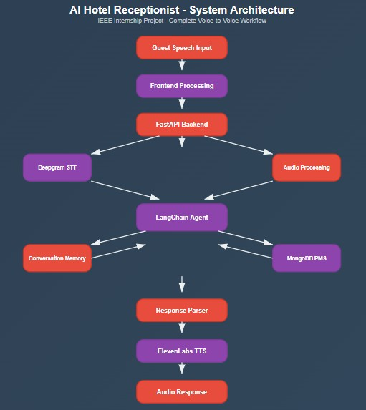

Implementation Details
The development of the AI Hotel Receptionist was carried out in two distinct stages, each focusing on a core aspect of the system: speech interaction and intelligent database integration.
In the first stage, the primary goal was to establish a speech-to-speech workflow. This began with integrating Deepgram’s Nova-2 API for Speech-to-Text (STT), enabling accurate transcription of guest queries. On the output side, ElevenLabs’ Monolingual v1 API was implemented for Text-to-Speech (TTS), producing natural and human-like responses. Considerable effort was invested in audio handling, where tools such as pydub and ffmpeg were configured to manage multiple audio formats, including webm streams from the browser. Parallel to this, the frontend interface was developed using HTML, CSS, and JavaScript. The frontend leveraged the MediaRecorder API for capturing speech, asynchronous fetch requests for sending audio files to the backend, and dynamic placeholders (Listening…, Thinking…) to enhance user interaction. At the end of this stage, the system could reliably convert speech input into audio responses, completing a basic conversational loop.
The second stage focused on adding intelligence and hotel-specific knowledge. A MongoDB database was created to act as a property management system (PMS), storing information such as room types, availability, and pricing. To query this database intelligently, the project adopted LangChain’s ReAct agent combined with the MongoDB toolkit, enabling natural language questions to be translated into structured queries. A FastAPI backend was then developed to host this agent, exposing endpoints that connected the AI reasoning layer to the frontend. Finally, the existing frontend was extended to interact with the new backend, ensuring that guest queries could trigger database lookups and return both spoken and text-based responses.
Through this staged approach, the project evolved from a simple speech pipeline into a context-aware AI receptionist, combining speech technologies, database integration, and real-time web interaction.

Result

The implementation of the AI Hotel Receptionist successfully demonstrated the integration of speech processing, intelligent reasoning, and property management data retrieval into a seamless end-to-end system. By the end of development, the project was capable of conducting real-time conversations with guests, handling both voice input and voice output while maintaining contextual continuity.
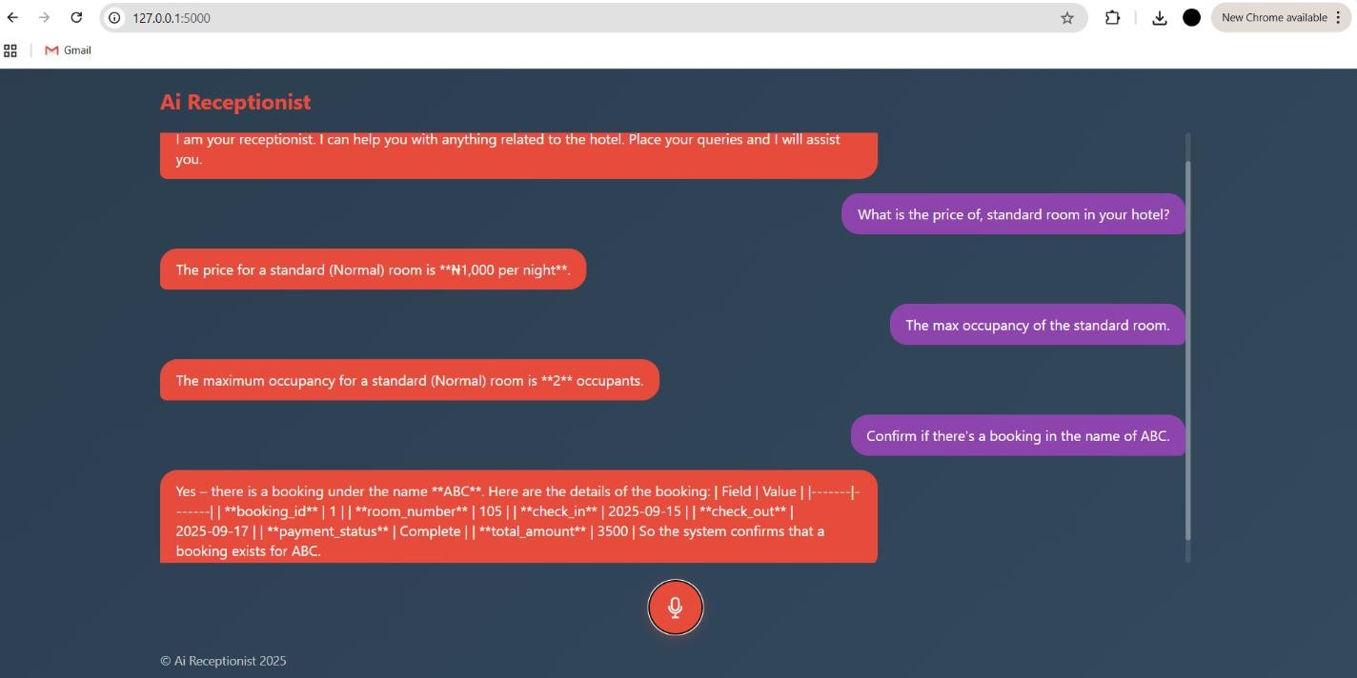

Fig 1.(User interface with prompts)

Sample Workflow: -

Voice Prompt: -
“What is the price of a standard room in your hotel”

Agent Voice Response: -
“The Price for a standard room is Rs1000 per night”

Voice Prompt: -
“what is the max occupancy”

Agent Voice Response: -

“The max occupancy for a standard room is 2”

Voice Prompt: -
“Can you confirm if there’s booking in the name ABC”

Agent Voice Response: -
“Yes there is a booking in the name ABC, here are the details booking id : 1
room number : 105 check in : 2025-09-15 check out : 2025-09-17
payment status : complete total amount : Rs 3000
”
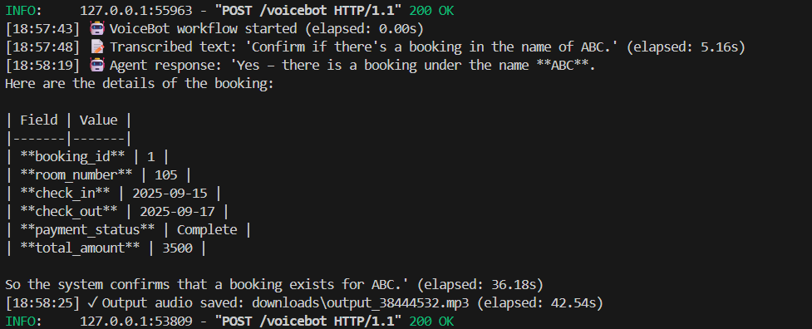
Fig 2.(Terminal Output)

Conclusion
The AI Hotel Receptionist project marks the successful completion of a system that blends speech interaction technologies with intelligent reasoning and hotel database management. Unlike conventional chatbots or isolated booking systems, this solution was deliberately built in stages, starting with a reliable speech-to-speech workflow and gradually evolving into a full-fledged receptionist capable of handling real hotel-related queries.
One of the most valuable learnings from the project was understanding how to orchestrate multiple services into a single, unified workflow. We gained practical experience in handling real-time audio pipelines, configuring speech recognition APIs to work with browser-generated formats, and optimizing text-to-speech latency to ensure smooth conversational flow. The integration of LangChain agents with a custom database further deepened our knowledge of how large language models can be combined with structured data systems to provide accurate, context-aware responses.
The journey also involved several struggles and challenges. A recurring issue was audio format compatibility, where the browser’s webm; opus recordings could not be directly processed, requiring careful setup of ffmpeg and pydub. Another challenge lay in parsing raw model outputs; without the custom parser, the AI often produced tables and markdown symbols that were unsuitable for speech. Ensuring conversation continuity through memory modules also required experimentation to strike the right balance between context retention and performance. These hurdles, though difficult, were crucial in shaping the robustness of the final system.
Looking ahead, the future scope of the project is wide-ranging. The receptionist can be extended to include automated booking confirmations via email or SMS, support for multiple languages to cater to international guests, and persistent memory storage using databases like Redis or MongoDB Atlas for long-term personalization. Further, integration with payment gateways and hotel management systems could allow the AI to handle not just inquiries, but also end-to-end reservation workflows.
In terms of industry impact, such AI receptionists have the potential to transform hospitality operations. Hotels can offer 24/7 multilingual guest support without significantly increasing operational costs. The system ensures faster responses, minimizes errors, and can handle high volumes of queries simultaneously — something that is challenging for human staff alone. While it is not a replacement for human receptionists, it can act as a scalable support system, allowing human staff to focus on tasks requiring empathy and complex problem-solving.
Overall, this project demonstrates both the technical feasibility and practical potential of using AI to reshape the future of guest engagement in the hospitality industry.

